Mr. Seán Costello
50, Saval Park Road
Dalkey
Co Dublin
A96WC97
To: An Coimisiún Pleanála
64 Marlborough Street
Dublin 1
D01 V902
Date : 8th October 2026

Re: Third-Party Appeal against the decision of Dún Laoghaire-Rathdown County Council
Planning Reference: D26A/0149/WEB
Site: Lillegard, 1 Saval Park Road, Dalkey, Co. Dublin
Dear Sir/Madam,
I wish to appeal the decision of Dún Laoghaire-Rathdown County Council to grant permission for the development under Planning Reference D26A/0149/WEB.
In compliance with the statutory regulations I enclose herewith payment for the sum of €220 as the statutory appeal fee in this instance for the making of a third party appeal. I enclose with this appeal a copy of the letter of acknowledgement from the Planning Authority in respect of their objection/observation relating to the planning application as described above.
I am a resident in the immediate vicinity of the application site on Saval Park Road and will be directly affected by the proposed development. My concerns relate principally to the scale and intensity of the development, its impact on residential amenity, overlooking and overbearing effects, access and traffic safety, parking, construction impacts and drainage/infrastructure.
I do not object to the principle of residential development of the site. My concern is that the particular form, scale, layout and intensity of the permitted development would materially and unacceptably affect the established residential amenities of neighbouring properties and the character and functioning of Saval Park Road.

1. Excessive density and intensity of development
The proposal would replace a single existing dwelling with four dwellinghouses on a relatively small 822 m² constrained residential site.
The issue is not simply the numerical density of four units, but whether the resulting development is appropriate to the site and its surrounding residential context.
The proposed arrangement places substantial built development across the site, including development to the rear and a three-storey dwelling. In my view, the cumulative effect is an intensity of development which is out of keeping with the established pattern of development in the immediate area.
I respectfully ask An Coimisiún Pleanála to assess the density together with:
- the amount and distribution of built form;
- the height and massing of the proposed houses;
- the extent of rear development;
- separation distances from existing houses and private open spaces;
- the resulting degree of overlooking and enclosure;
- the adequacy of private and communal external space;
- parking and vehicular circulation; and
- the capacity of the site and surrounding road network to accommodate the resulting intensity of use.
The relevant planning consideration is therefore the quality and consequences of the resulting development rather than density considered in isolation.
2. Height, scale and overbearing impact
I have particular concern regarding the proposed three-storey dwelling.
The additional storey, when combined with the position and mass of the proposed buildings, has the potential to create an undue sense of enclosure and visual dominance for neighbouring properties.
The impact of a building should not be considered solely by reference to its footprint. Height, bulk, orientation, proximity to boundaries and the relationship between upper-floor windows and neighbouring gardens and houses are all relevant to residential amenity.
I respectfully ask the Commission to consider whether the three-storey element is appropriately scaled and positioned having regard to the established two-storey residential environment and the close relationship between the proposed development and neighbouring properties.
In particular, the Commission should assess:
- direct and oblique views towards neighbouring properties;
- the effect of upper-floor windows;
- the effect of the building mass when viewed from neighbouring gardens;
- the loss of openness and outlook;
- potential overshadowing;
- the cumulative effect of several new buildings rather than considering each dwelling in isolation; and
- whether the development would result in an unacceptable overbearing impact.
3. Overlooking and loss of privacy
The proposed development introduces a substantial number of new residential windows and elevated floor levels into a site immediately adjoining established residential properties.
The proposed three-storey element is of particular concern because upper-floor windows can introduce views which did not previously exist.
I ask the Commission to examine the actual separation distances and sightlines between proposed windows, balconies or terraces, where applicable, and neighbouring houses and private gardens.
The assessment should consider not only direct overlooking but also oblique and diagonal views from upper-floor accommodation and rear-facing windows.
Any mitigation should be demonstrably effective and should not rely solely on future planting which may take many years to mature.
4. Access and traffic safety on Saval Park Road
The proposal includes a widened pedestrian and vehicular entrance onto Saval Park Road.
The increased intensity of residential use will necessarily generate additional vehicle movements, pedestrian movements, deliveries, refuse collection and visitor activity.
I ask the Commission to consider whether the proposed access is appropriate having regard to:
- the width and geometry of Saval Park Road;
- existing pedestrian movements;
- visibility at and around the entrance;
- vehicle turning movements;
- interaction between vehicles and pedestrians;
- on-street parking;
- construction traffic; and
- the cumulative effect of additional vehicle movements on the established residential street.
The fact that the entrance is based on an existing vehicular entrance does not, in itself, demonstrate that the widened entrance and increased intensity of use will be safe and satisfactory.
5. Parking and internal vehicle movements
The proposal provides four off-street parking spaces for four dwellings.
I ask the Commission to examine whether the parking provision is adequate in practical terms and whether the layout allows vehicles to enter, leave and manoeuvre safely without creating pressure for additional on-street parking. Essentially it is forming a back garden ‘cul-de-sac’ with limited space for movement of vehicles that will ultimately have an effect on ‘on street’ parking hence the assessment should take account of visitor parking, deliveries, service vehicles, refuse collection and the realistic parking requirements of the proposed dwellings.
Particular attention should also be paid to whether vehicles can exit the site in a forward gear and whether the internal arrangement could result in vehicles reversing towards or across the public footpath.
6. Construction impacts
The demolition of the existing dwelling and construction of four new houses will involve substantial construction activity on a constrained residential site.
I ask that adequate safeguards be imposed in relation to:
- construction traffic;
- hours of construction;
- deliveries and unloading / contractor parking;
- dust and air quality / noise and vibration;
- protection of neighbouring properties;
- protection of boundary walls and structures;
- site security;
- mud and debris on the public road;
- pedestrian safety; and
- protection of existing trees, landscaping and drainage infrastructure.
Given the proximity of neighbouring houses, construction impacts should be assessed as a material planning consideration rather than treated as an incidental matter.
The site entrance faces onto ‘Saval Park Gardens’ which in itself is a ‘cul-de-sac’, with single point of access and egress onto Saval Park Road at this exact juncture, facing onto the Lillegard Property. The volume of traffic on the Saval Park Road has increased significantly due to the amount of visiting patrons to Barnhill Stores, with parking overflow directly onto Saval Park Road.
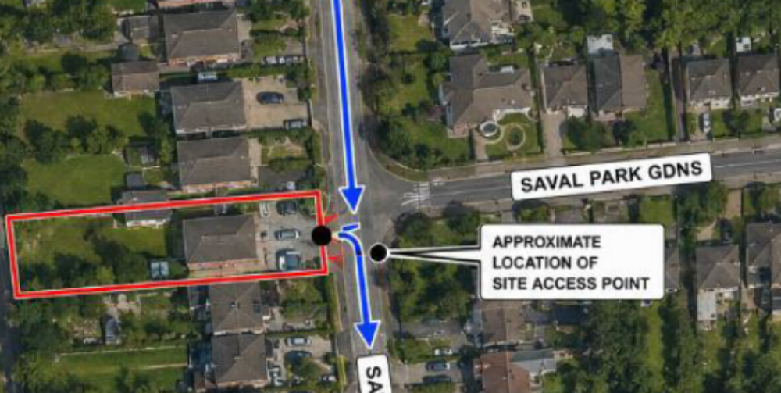
7. Drainage and surface-water management
I have concerns regarding the capacity of the site and surrounding infrastructure to accommodate the additional residential development and associated hardstanding.
The planning documentation identifies a combined sewer in Saval Park Road. I ask the Commission to satisfy itself that the proposed drainage arrangements are sufficiently robust for the increased intensity of development and that the proposal will not result in increased surface-water runoff affecting neighbouring properties or the public road.
In particular, consideration should be given to:
- the increase in impermeable surface area;
- surface-water attenuation;
- discharge rates;
- the capacity of the receiving drainage infrastructure;
- finished ground levels;
- the relationship between proposed levels and neighbouring properties;
- potential exceedance flows; and
- the maintenance and long-term effectiveness of proposed drainage measures. Any uncertainty regarding drainage should be resolved before permission is confirmed.
8. Impact on established residential amenity
The site is within an established residential area.
The Council's zoning objective is R2, Existing Residential, Objective A, which seeks both residential development and protection of existing residential amenities.
I submit that the permitted development, taken as a whole, risks causing an unacceptable deterioration in the residential amenities enjoyed by neighbouring residents through the combined effects of:
- increased building density;
- additional building height;
- overbearing built form;
- overlooking and loss of privacy;
- increased vehicular activity;
- parking pressure;
- construction activity; and
- potential drainage impacts.
These impacts should be assessed cumulatively rather than as separate isolated matters.

9. Need for a more appropriate design response
I respectfully submit that residential development may be capable of being accommodated on the site, but the particular scale and arrangement permitted requires reconsideration.

10. Fundamental error in Site Notice Date / misleading information
Also, within my appeal I also wish to highlight the fact that the initial site notice erected at the Lillegard site was incorrectly dated and very much misleading. See below excerpt of the notice – confirming that the site notice was dated 27/02/2025 and should have read 27/02/2026?
This error is misleading and could have possibly deterred site observers from making and appeal on the assumption that they were too late? This also draws into question why the DLRCOCO did not recognise the error and why the process was not halted at the outset by DLRCOCO due to this fundamental planning error?

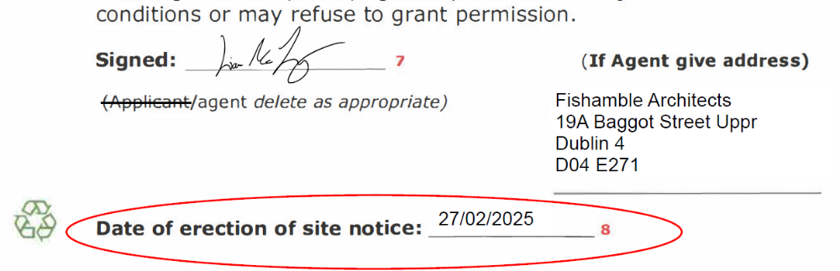

To summarise my appeal: Based on the above fundamental concerns as listed above, I ask An Coimisiún Pleanála to reconsider the permission and, having regard to all of the matters set out above and the full planning file, and to refuse permission.
Alternatively, if the Commission considers that the principle of development is acceptable, I ask initially that the scheme be rejected or at the very least substantially amended or appropriately conditioned to address the identified residential amenity, access, parking, safety and wellbeing of pedestrians and road users, construction and associated drainage concerns.
Yours faithfully,

Mr Sean Costello

